/s//ch/ afwisselen

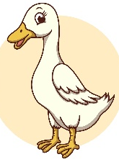

aa p oo l
oo t o p
ie t aa r
i p i l

